**SIGNIFICANCE of the STARLING ROOST at LLANDEGLEY RHOS and HENDY BANK**

**MAJOR STARLING ROOST at LLANDEGLEY RHOS in excess of 200,00 birds**

The Starling roost in the conifer plantation adjacent to Llandegley Rhos Common, Radnorshire, Powys is home to any number of starlings from 150,000 to more than 200,000 birds in the winter season. Birds have been returning to this area since the late 1970’s and now have a well - established roost at Llandegley Rhos. Watching a starling murmuration is one of nature’s winter wonders, and something that can be readily experienced and enjoyed by all in Radnorshire at this roosting site via public rights of way.

The size and significance of this roost and the spectacular displays of murmurations, needs to be recognised and protected. Although this roost is not on an RSPB reserve, a Wildlife Trust reserve, and is not part of an SSSI, or is on a listed building or in the centre of a city, it is, nevertheless, home to a very significant number of red listed starlings. These starlings are entitled to all the means of protection available to them by way of our environmental laws, to ensure that bio-diversity across Wales is not only recognised but is maintained, enhanced and enjoyed by all. Taking the figures quoted in the article below, for major sites in Wale, and adding the roosting birds at Llandegley Rhos the total number of birds is 650,000 -700,000 starlings. On this listing the Llandegley Rhos roost is the third largest in Wales and the fourth largest here listed in the UK. The significance of the Llandegley Rhos roost, based on these figures, is that Llandegley represents anything between 23% - 30 % of the total number of starlings in the listed major roosts in Wales.

**REF: BIRDWATCH MAGAZINE : article Sam Viles 23.12.2016**

**Top 10 UK Starling Murmuration sites**

**RSPB Sites**

Minsmere Reserve Suffolk Reedbeds 30,000 birds

Saltholm Teeside Yorkshire Reedbeds 20,000 birds

Leighton Moss and Morecambe Bay Lancashire Reedbeds 120,000 birds

Ham Wall and Shapwick Heath NNR Somerset Levels Reedbeds < 1 million birds

**Newport Wetlands Gwent Reedbeds 100,000 birds**

**Malltraeth Marsh Anglesey Reedbeds, marshes, wet grassland 350,000 birds**

**This site also incorporates an SSSI**

**Listed Buildings**

**Aberystwyth Pier Grade 11 Ceredigion 50,000 birds**

Brighton Pier Grade 11* Sussex <100,000 birds

**Urban Centres**

Belfast city centre Northern Ireland 30,000 birds

Gretna Green - Rigg Scotland < 1 million birds

It is interesting to observe that from a 2016 UK list of top 10 Starling murmuration sites, compiled by Birdwatch in conjunction with RSPB, BTO and BirdLife International, six of these sites are RSPB reserves, two sites have listed building status and two are in or just outside a major city and a town. Looking at this list, there are three roosting sites in Wales all of which enjoy some form of protected status.

The Llandegley Rhos roost does not benefit from the same degree of protection as the sites listed below, although it is the biggest roost in Radnorshire and probably in Mid-Wales. Such a significant roosting site containing hundreds and thousands of red listed starlings must be afforded the necessary environmental protection that this valuable wildlife asset requires, rather than being threatened with removal to facilitate an inappropriate development. Lynden Rees-Roberts

 23/12/2016

     Winter spectacles: 10 top UK Starling murmurations

Like clouds of smoke, large flocks of [Starlings](https://www.birdguides.com/species-guide/ioc/sturnus-vulgaris) roll and churn through the evening sky, creating ever-changing shapes as they gather before diving into their chosen roost sites. A well-known garden bird, Starlings take on a whole different persona in the winter months, when their roosting behaviour becomes one of Britain's greatest wildlife spectacles. Many thousands of birds come together in large gatherings to reduce the risk of attack from avian predators before dropping in to roost.

[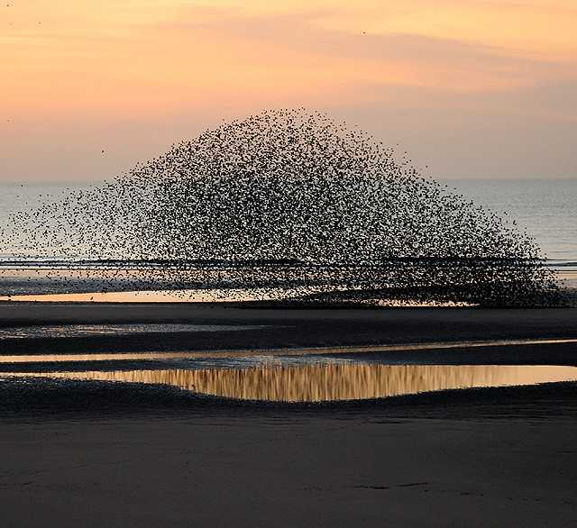](https://www.birdguides.com/gallery/birds/sturnus-vulgaris/460234)  
[Starling](https://www.birdguides.com/species-guide/ioc/sturnus-vulgaris) murmuration over Blackpool beach, Lancashire (*Photo:*[*Jackie Moreton*](http://dmoreton.co.uk/))

Starlings leave their roosts during the day and go off to feed, some up to 20 miles away. They return in the afternoon and the murmurations usually start an hour or so before sunset. Murmurations can be seen in small numbers at many places across the country, but are at their most dazzling at a few select sites where numbers can reach hundreds of thousands of birds. Below is a selection of 10 of the best sites at which to experience this spectacle.

Minsmere RSPB

Ensconced on the coast of Suffolk, Minsmere is one of Britain's most well-known RSPB reserves. In the past, Starling flocks along the Suffolk coast were mobile over a number of sites, but the reedbeds off Minsmere's North Wall have become a regular haunt in the last couple of years, with gatherings of up to 30,000 seen already this December. A short walk from the visitor centre car park, an evening stint here can also be productive for other star winter species, with wildfowl, gulls and waders, including regular roosting [Bewick's Swans](https://www.birdguides.com/species-guide/ioc/cygnus-columbianus-bewickii) and [Caspian Gulls](https://www.birdguides.com/species-guide/ioc/larus-cachinnans).

*Minsmere RSPB, Sheepwash Lane, Saxmundham IP17 3BY*

[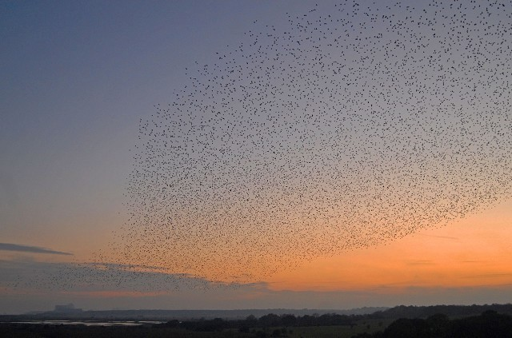](https://www.birdguides.com/gallery/birds/sturnus-vulgaris/412014)  
[Starlings](https://www.birdguides.com/species-guide/ioc/sturnus-vulgaris) gather over Minsmere RSPB, with Sizewell B power station on the horizon (*Photo:*[*Jon Evans*](http://www.jonevansbirding.blogspot.com/))

Saltholme RSPB

Containing around 20,000 individuals, the Starlings at Saltholme gather against a stark backdrop of heavy industry. As they arrive, the birds crowd on pylons which overlook the wet reedbed at Haverton, a safe roost site because mammalian predators cannot get to them without swimming. The murmurations are best experienced from the Haverton Viewpoint, but be sure to leave yourself enough time to return to the visitor centre as the whole site is closed to the public at 4 pm in winter. The RSPB hold a number of 'Soup and Starling' events throughout the winter which allow for a more immersive experience — and soup — past the reserve's closing times. Additional attractions are provided by the large winter wildfowl flocks and birds of prey, which include [Short-eared Owls](https://www.birdguides.com/species-guide/ioc/asio-flammeus), [Peregrine Falcons](https://www.birdguides.com/species-guide/ioc/falco-peregrinus)and [Merlins](https://www.birdguides.com/species-guide/ioc/falco-columbarius); the last two species are often seen harassing the Starlings making for some breathtaking, fast-changing patterns and shapes.

*Saltholme RSPB, Seaton Carew Road, Stockton-on-Tees, TS2 1TU*

Leighton Moss RSPB

Numbering up to 120,000 in some years, the Starlings spend the night in Leighton Moss's extensive reedbeds, in the company of resident [Bitterns](https://www.birdguides.com/species-guide/ioc/botaurus-stellaris) and [Bearded Tits](https://www.birdguides.com/species-guide/ioc/panurus-biarmicus). The shapes of their sky dancing are perhaps best observed from Lilian's Hide near to the visitor centre, which is one of the larger sheltered viewing points on the reserve and is wheelchair accessible.

*Leighton Moss RSPB, Storrs Lane, Silverdale, LA5 0SW*

[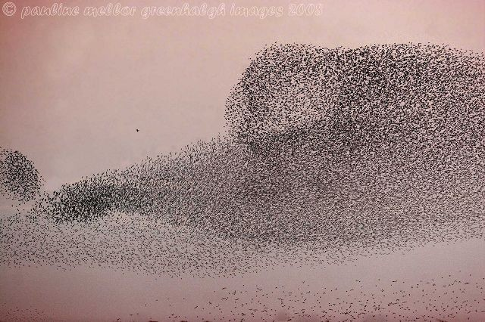](https://www.birdguides.com/gallery/birds/sturnus-vulgaris/325022)  
[Starlings](https://www.birdguides.com/species-guide/ioc/sturnus-vulgaris) at Leighton Moss RSPB in November 2008 — spot the marauding [Sparrowhawk](https://www.birdguides.com/species-guide/ioc/accipiter-nisus)! (*Photo:*[*Pauline Greenhalgh*](http://pmgi.zenfolio.com/))

Newport Wetlands RSPB

Often gathering on the power lines by the reedbeds before dropping into them to roost, this site often attracts the attentions of the local pylon-nesting Peregrine Falcons. As the sun sets, they lift off the cables and flock over the largest reedbed in Wales. Accounting in area for 10 per cent of all the reedbeds in the principality, the roost in late November contains around 100,000 birds at its peak. Unsurprisingly, other reedbed species can also be seen here, including Bearded Tits and regular wintering Bitterns. The murmurations can be seen from most vantage points on the reserve.

*Newport Wetlands RSPB, West Nash Road, NP18 2YH*

[Starlings](https://www.birdguides.com/species-guide/ioc/sturnus-vulgaris) impress onlookers at Newport Wetlands (*Video:*[*Margaux Doey*](https://www.youtube.com/channel/UCu74ZA1Sfk4gklNAv8XJuiw))

Belfast

Rome's urban starlings are now a regular TV feature, most notably including the BBC's recent Planet Earth II. Large city centre roosts such as this are sadly a very uncommon sight nowadays, but at least one remains: the gathering in the centre of Belfast. The largest of its kind in Northern Ireland, it plays host to around 30,000 birds. Gathering from all parts of the city and its environs, they coalesce into a single massive flock wheeling in unison as they prepare for nightfall, before flying under the Albert and Queen's Bridges where they roost for the night.

*Albert Bridge, Belfast, BT7 2DS*

Malltraeth Marsh RSPB

Malltraeth, on the coast road towards Rhosneigr, is a relatively unknown RSPB reserve, but encompasses 273 hectares of reedbeds, marshes and wet grassland. Containing up to 350,000 birds some years, this roost is surprisingly unfamiliar to many, but its large number of birds make it one well worth exploring. The marsh is a vital feeding area for migrating and wintering waders and wildfowl, including the area's important Northern Pintail population, and also plays host to wintering Bitterns. The roost is perhaps best viewed from by the reserve's Tai'r Gors car park.

*Tai'r Gors, Malltraeth Marsh, Pentre Berw, LL60 6LB*

Gretna

Far more famous for eloping lovers than avian delights, Gretna Green also plays host to one of the country's larger murmurations, often holding more than a million birds. It is in fact so imposing that that sky often turns black due to sheer numbers, their wingbeats providing a flying orchestra. This mobile roost was in previous years located just to the south of the motorway services but is now usually found just to the west of the hamlet of Rigg, to the west of Gretna, and is best viewed from various points along the B721 — watch out for them perched in trees or on pylons before going to roost.

*Rigg, DG16 5JF*

[Starling](https://www.birdguides.com/species-guide/ioc/sturnus-vulgaris) murmurations at Gretna Green (*Video:*[*Video: wildaboutimages*](https://www.youtube.com/user/wildaboutimages))

Aberyswyth Pier

This small Welsh seaside town is a popular one with tourists in the summer months, but in recent years its infamous starling roost has led to sizeable crowds of residents, students and tourists gathered along the seafront in the depths of winter. Constructed using a maze of iron latticing, Aberystwyth's Royal Pier opened in 1865, and the aforementioned columns provide a labyrinth of roost spots. Wheeling over the town's waterfront, the birds can number over 50,000 strong. Best viewed from anywhere along the promenade, or the pier itself, this particular spot has the added advantage of a number of first-rate fish and chip shops, a welcome delight after an afternoon's starling counting.

*Marine Terrace, Aberystwyth SY23 2AZ*

[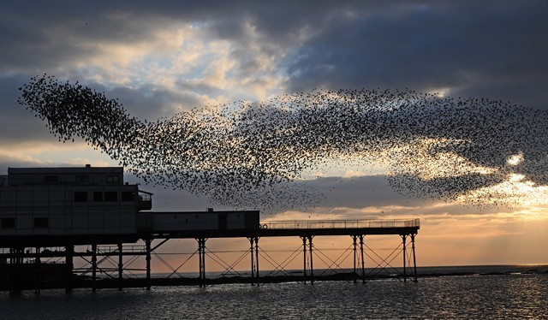](https://www.birdguides.com/gallery/birds/sturnus-vulgaris/377703)  
[Starlings](https://www.birdguides.com/species-guide/ioc/sturnus-vulgaris) flocking over Aberystwyth pier (*Photo: Kev Joynes*)

Brighton

Probably the most well-known of all 10 sites, Brighton's birds congregate on the derelict West Pier, by the town's new sky tower. But the views from this observation tower are no match for those found when the starlings are in town. One of the more picturesque roosting sites, the charred corpse of the fire-scarred pier has provided an iconic backdrop to countless numbers of award-winning photographs. Sometimes numbering into the hundreds of thousands, the flocks can be seen from anywhere along the town's seafront before dropping onto West Pier, as well as neighbouring Palace Pier and under the Marina Wetherspoons.

*Kings Road, Brighton, BN1 2FA*

Shapwick Heath NNR & Ham Wall RSPB

By some distance the largest roost in the UK, usually encompassing in excess of a million individuals — and in the winter of 1999 reaching an estimated size of 6 million! They are so numerous that the water below their chosen roost soon becomes polluted, and they use a slightly different location most days. Such a large gathering brings with it a whole host of avian predators. Both [Tawny](https://www.birdguides.com/species-guide/ioc/strix-aluco) and [Barn Owls](https://www.birdguides.com/species-guide/ioc/tytonidae) are known predators, and [Marsh Harriers](https://www.birdguides.com/species-guide/ioc/circus-aeruginosus), [Sparrowhawks](https://www.birdguides.com/species-guide/ioc/accipiter-nisus), Merlins and Peregrines are regular visitors. The Starlings can be just as spectacular when they leave their roost in the morning as tens of thousands of birds erupt out of the reeds all at once, which usually happens about half an hour before sunrise.

Understandably, this roost can attract large crowds. So popular is the roost on the Somerset Levels that the RSPB have set up a Starling Hotline outlining their last known locations, which can be reached on 07866 554142. Arriving early to beat the hordes provides ample time to explore the rest of this large chain of reserves. Other special wildlife in the Avalon Marshes area includes [Great White Egrets](https://www.birdguides.com/species-guide/ioc/ardea-alba), Bitterns, Otters, reintroduced [Common Cranes](https://www.birdguides.com/species-guide/ioc/grus-grus), along with large numbers of wildfowl and waders, and often a good chance of something rarer.

Access is best achieved using the main car park at Ham Wall, from where both here and Shapwick are easily reached. There is a small visitor centre here, with the car park closing at 18:30 during the winter months. There is also parking on the Shapwick side at Avalon Marshes Centre, with toilets and a café.

*Ham Wall RSPB, Ashcott Road, Meare, BA6 9SX*

[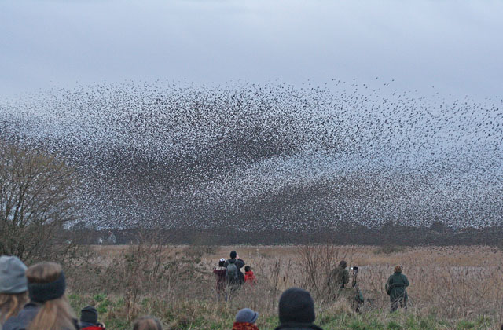](https://www.birdguides.com/gallery/birds/sturnus-vulgaris/620637)  
The impressive show at Ham Wall RSPB draws large numbers of admirers (*Photo: R. Luckwill*)

*Written by:****Sam Viles***