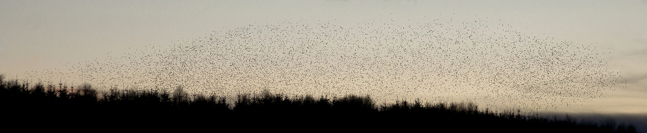

Starlings arriving to roost at the Hendy Plantation, Llandegley Rhos Common, 28thNovember 2017

**THE BIG STARLING**

**WINTER WATCH**

Come and experience thousands of starlings converging on this major roost

**LLANDEGLEY RHOS COMMON**

**Near Penybont, Powys. LD1 5UG**

**SUNDAY 28th JANUARY – 3.45pm**

Muster at Pye Corner – turning off the A44 below Radnor Forest

(See map for details)

Llandegley Rhos Common is accessed by the Public Byeway which

leads across the common towards the plantation.

Suggested viewpoints are from the Common and from Blaen Edw Bank,

accessed by a footpath from the byeway.

Sunset is at 4.55 pm on the 28th January, and the starlings should be

streaming in for twenty minutes from about 4.20 pm.

Sturdy warm water proof clothing and footwear recommended.

Bring cameras, binoculars, a warm drink, and a torch.

Details: 01544 267418

**Starlings are on the RSPB / BTO Birds of Conservation Concern 4 Red List**

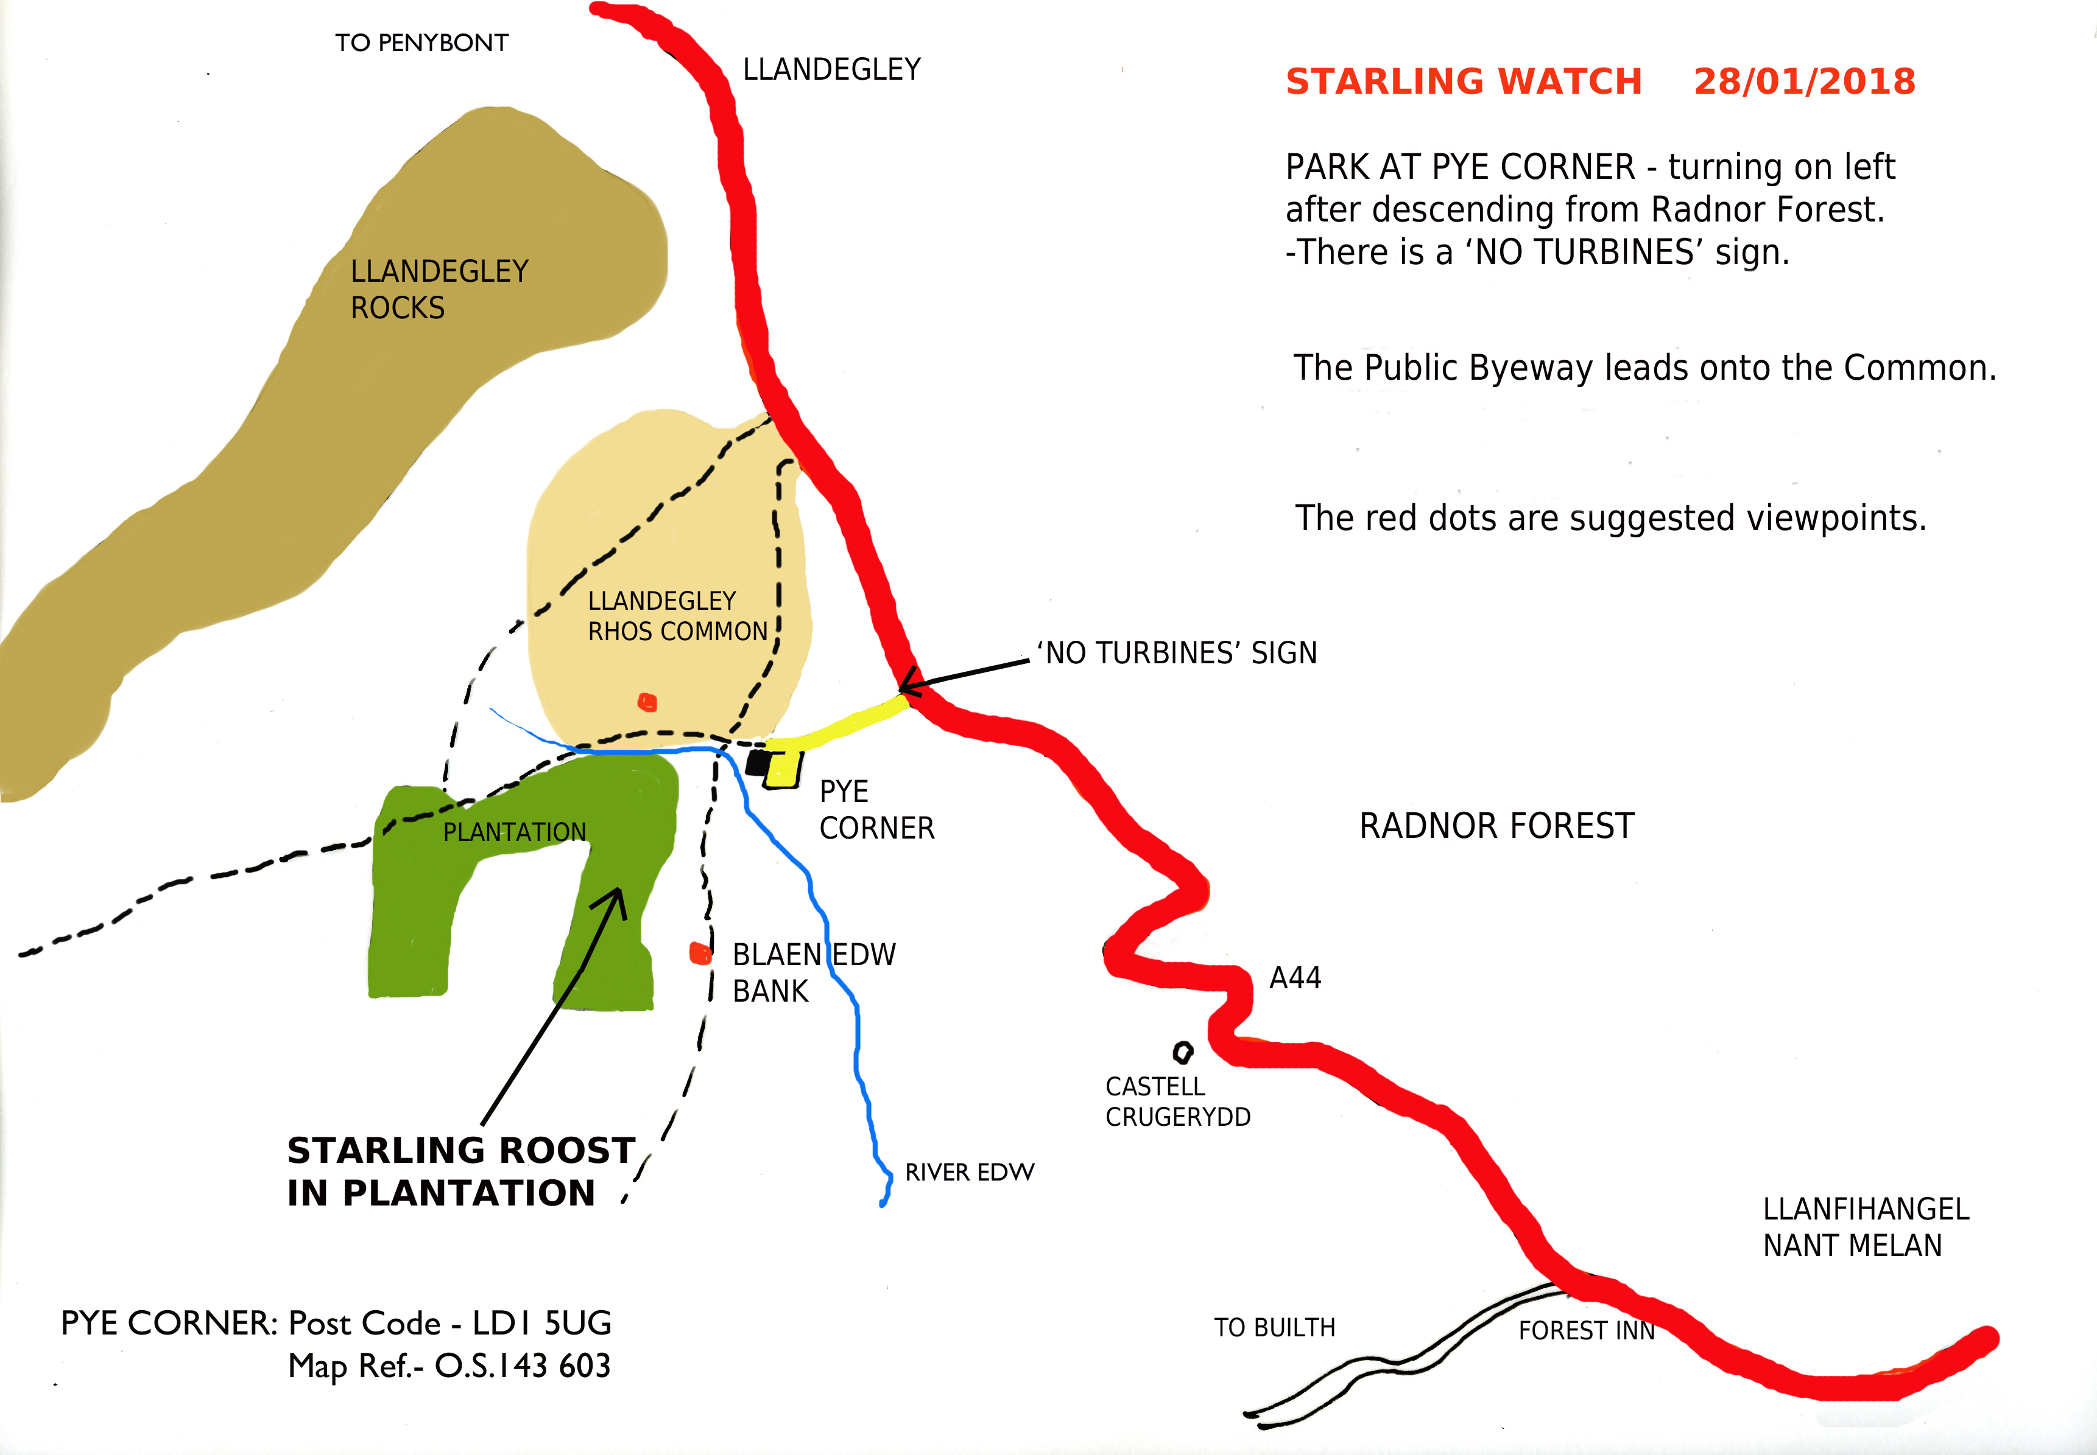

**Big Starling Winter Watch: January 28th 2018**

More than 80 intrepid folk braved a distinctly grey and windy January afternoon to come and watch the inspiring sight of tens of thousands of starlings coming in to their winter roost in the conifer plantation adjacent to Llandegley Rhos Common. As well as people from the local area, many had travelled some distances, from Rhayader, Presteigne, Shrewbury, Church Stretton, Kington, Clyro and Ross-on-Wye to experience this starling display. Amidst an atmosphere of excitement and anticipation, groups of people of all ages, from families with young children to grandparents with friends and a helping hand, made their way along the public bye-way across the Common and waited patiently for the starlings to arrive. Some twenty or so intrepid bird watchers crossed the River Edw and made their way up onto Blaen Bank for a better bird’s eye view of the roost.

**People arriving at Llandegley Rhos Common**

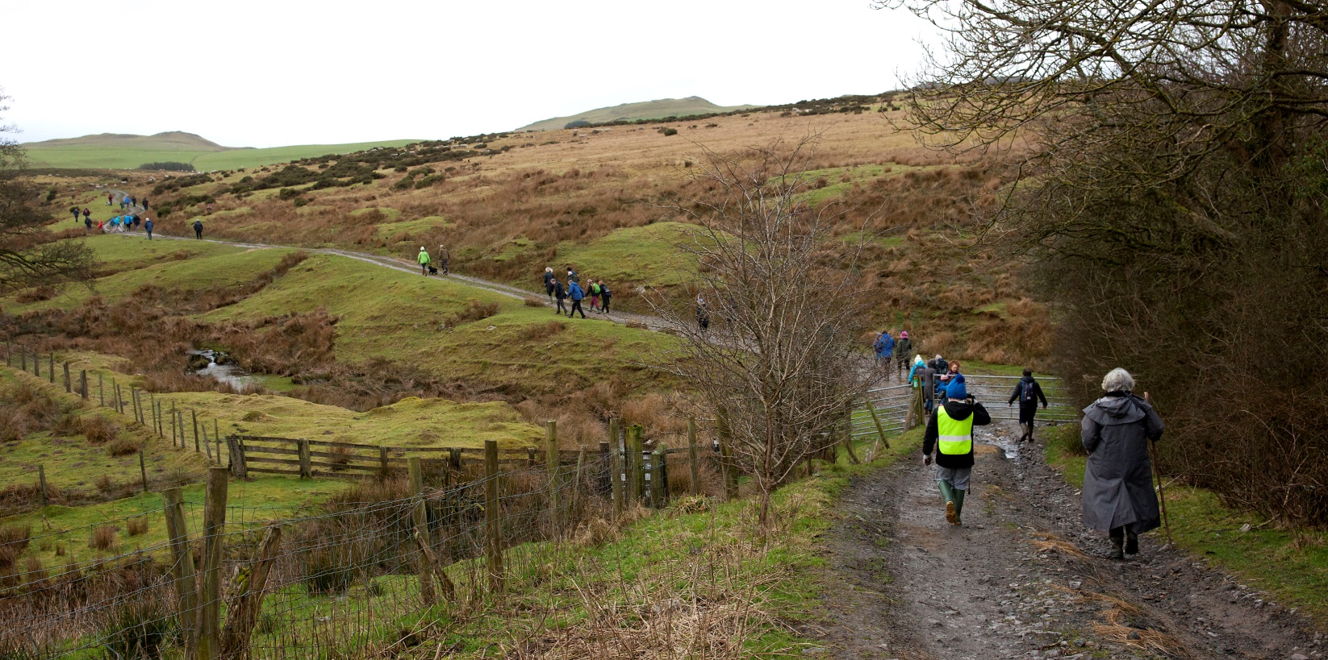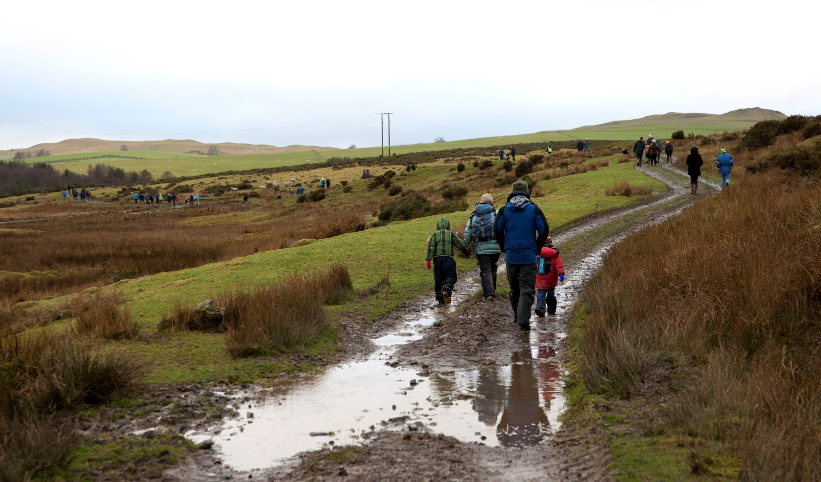

And the starlings did not disappoint. They started to arrive at 4.25pm and continued to come in from all quarters north, south, east and west, for another 25 minutes. Depending on where you were standing, as the frequency of the flocks increased, you found yourself turning like a weather cock, to keep up, as thousands of birds streamed and swirled in across the common and over the pine trees creating beautiful, mesmerising murmurations in the winter sky. By five o clock we had lost the light, although a few late arrivals were still flying in, but it was time for us to leave and seek our own roosts for the night, happy that we had shared one of nature’s winter wonders and probably experienced the largest gathering of starlings in Mid-Wales.

Lynden Rees-Roberts

**Two starling murmurations and a large incoming flock**

