**Starling**

[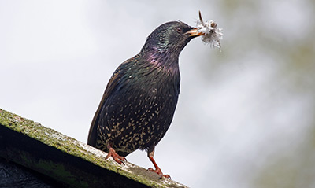](https://www.bto.org/sites/default/files/shared_documents/bird_month/Teal-Winter-Distribution-2007-11.gif)

With a somewhat undeserved reputation for being argumentative and greedy, the Starling is actually one of our most interesting birds. This highly sociable species exhibits a suite of fascinating behaviours, many of which can be seen in those individuals visiting our parks and gardens.

Birds of a feather

During the winter months, the numbers of Starlings present within Britain and Ireland are swelled by the arrival of individuals from breeding populations located elsewhere within Europe. The numbers arriving vary from one winter to the next and are influenced by weather conditions on the Continent. Wintering Starlings roost communally and vast flocks may congregate at favoured sites, typically performing amazing aerobatic displays (known as ‘murmurations’) before dropping into the roost, which may be a reedbed, a group of conifers or a human structure, such as a pier. With many thousands of birds using a roost there is the potential for nuisance, their droppings fouling the ground beneath and around the chosen site.

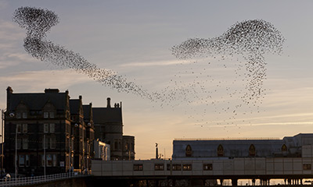

Starling Murmuration. Photograph by Jeremy Moore

These vast flocks have more humble beginnings, with small flocks of Starlings coming together as dusk approaches. Gradually, as more and more birds join the gathering, a huge pulsating flock is formed. As the light begins to fade so part of the flock will plunge down towards the chosen roost, almost as if testing its nerve to see who will be the first bird to drop into the roost itself. The birds have good reason to be nervous; these large gatherings attract the attentions of predators like Peregrine and Sparrowhawk.

[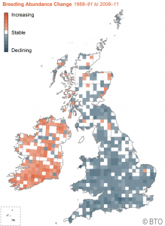](https://www.bto.org/sites/default/files/shared_documents/bird_month/starling-relative-abundance-change-1988-91-2008-11.png)

Map showing Starling relative abundance change  
in Britain and Ireland.   
**Click to enlarge**.  
[BTO Bird Atlas Mapstore](http://app.bto.org/mapstore/StoreServlet?id=457)

Britain needs more holes

With the first eggs laid as early as late March, our resident Starlings begin looking for nesting cavities very early in the year. The loss of suitable cavities is thought to be a contributory factor in the decline in Starling populations [witnessed over recent decades](http://app.bto.org/birdtrends/species.jsp?s=starl&year=2014). Cavities under roof tiles or within barge boards and soffits are now less common than they once were, reducing opportunities for the urban component of our Starling breeding population. Starlings will take readily to nest boxes of suitable size and with an entrance hole of 45mm diameter. Schemes, such as [National Nest Box Week](https://www.bto.org/about-birds/nnbw), which promote the erection of nest boxes, provide an opportunity for householders to attract these smart birds to their properties.

Male Starlings, which establish breeding territories from January onwards, attempt to defend a series of suitable nesting cavities in the hope that they will be able to attract several females. Competition for nest sites is high, which means that most male Starlings end up with a single cavity and just the one mate. It is not just the males who are opportunistic in their breeding behaviour. Females will not uncommonly deposit one of their eggs in the nest of another female (a behaviour known as brood parasitism). The females that do this tend to be ‘floaters’, birds that have yet to secure a mate or nest site. Many of these birds will go on to have a nest of their own later in the season so you may wonder why they dump an egg on another bird rather than wait. The answer may have something to do with the fact that early breeding is better, being more productive and giving the resulting fledglings more of the summer to gain independence; it also gives breeding pairs more opportunity for making a second breeding attempt.

[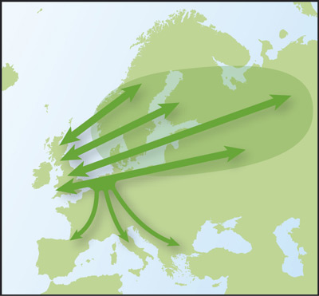](https://www.bto.org/sites/default/files/shared_documents/bird_month/Teal-Winter-Distribution-2007-11.gif)

Starling migration routes. © BTO

You are what you eat

Watch a group of Starlings probing a lawn and you will soon discover that they spend the summer months feeding mostly on soil-dwelling invertebrates, such as leatherjackets (the larvae of craneflies). From late summer the diet begins to change and the birds take increasing quantities of plant material. This seasonal shift in the Starling’s diet is matched by a number of morphological changes. Most notable of these is an increase in the length of the bird’s intestine, the additional length allowing the Starling to deal with the increased amount of plant material being taken – plant material is more difficult to digest than animal material.

Starlings show a certain amount of adaptability when it comes to food and feeding. In addition to probing the ground for invertebrates, they will also flycatch or actively pursue insects across the ground. Large food scraps, such as chips, are taken regularly and they have even been known to tackle small lizards, newts and frogs. This resourceful nature is one reason why the Starling has adapted so well to living alongside us within our urbanised landscapes.

**Help chart the changing fortunes of Starling through the weekly**[**BTO Garden BirdWatch scheme**](https://www.bto.org/volunteer-surveys/gbw)**.**

[More BirdFacts for this species](http://blx1.bto.org/birdfacts/results/bob15820.htm)

[Starling distribution and abundance maps on Bird Atlas Mapstore](http://blx1.bto.org/mapstore/StoreServlet?id=457)

[Starling BirdTrends](http://blx1.bto.org/birdtrends/species.jsp?s=starl&year=2014)

* [**Home**](https://www.bto.org/)
* [**About birds**](https://www.bto.org/about-birds)
* [**Volunteer surveys**](https://www.bto.org/volunteer-surveys)
* [**Science**](https://www.bto.org/science)
* [**Research & data services**](https://www.bto.org/research-data-services)
* [**My BTO**](https://www.bto.org/my-bto)
* [**News & events**](https://www.bto.org/news-events)
* [**Support us**](https://www.bto.org/support-us)
* [**Shop**](https://www.bto.org/shop)

**About Birds**

* [**BirdFacts**](https://www.bto.org/about-birds/birdfacts)
* [**BirdTrends**](https://www.bto.org/about-birds/birdtrends/2016)
* [**Bird Identification**](https://www.bto.org/about-birds/bird-id)
* [**National Nestbox Week**](https://www.bto.org/about-birds/nnbw)
* [**Book reviews**](https://www.bto.org/about-birds/book-reviews)
* [**Ornithological links**](https://www.bto.org/about-birds/ornithological-links)